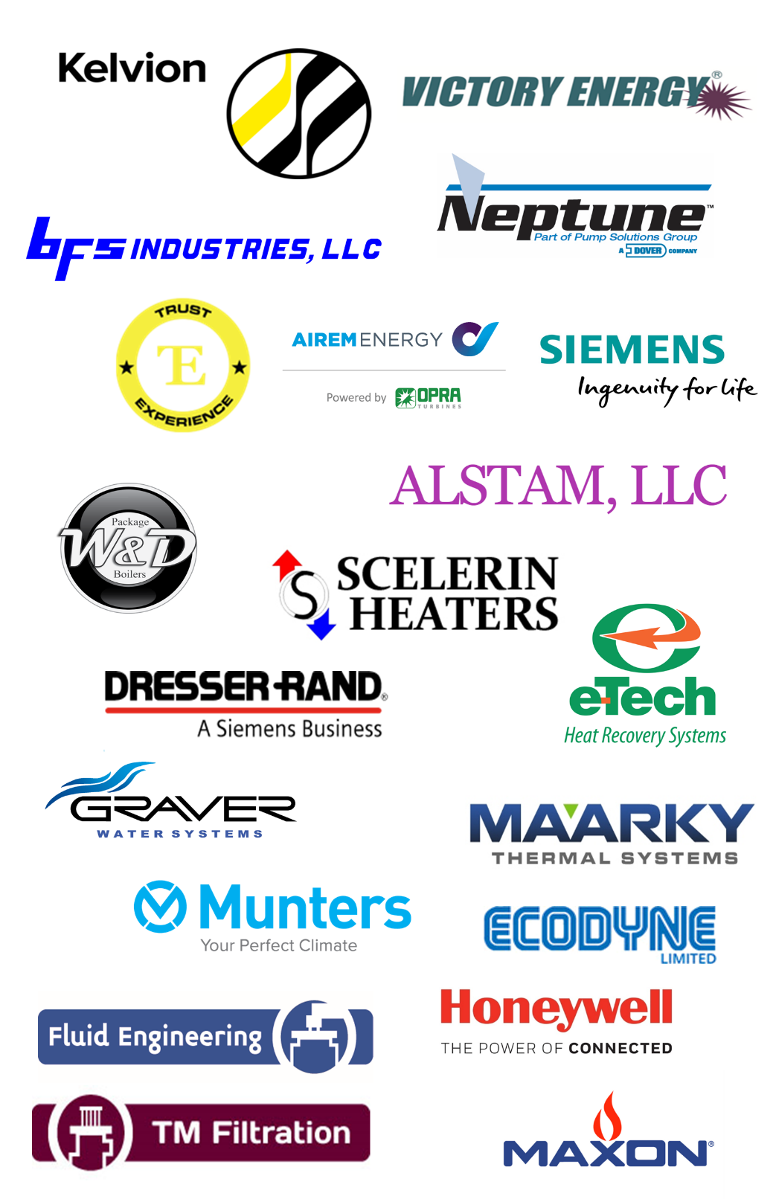

Pentad Associates, Inc.

PH: 303-688-4070

E-Mail: sam@pentadassoc.com Website: www.pentadassoc.com

MANUFACTURERS’ REPRESENTATIVE FOR INDUSTRIAL EQUIPMENT

Boilers
Firetube & Firebox (Wetback and Dryback) - Pressures up to 300 PSIG
Watertube (up to 500,000 lbs/hr) - Pressures up to 1250 PSIG
Waste Heat (up to 400,000 lbs/hr) - 900 PSIG.; 1-40 MW
Electric and Condensing (500,000-4 MM BTU/hr)

Burners
Low NOX / Ultra Low NOX, Gas & Oil (1 to 300 MM BTU/hr)
Duct, Rotary Kiln, Fluid Bed, Radial Wall, Ethylene Cracking; Process Heaters

Boiler Room Auxiliaries
Feedwater Systems, Critical Fuel Systems, Chemical Feed Systems
Burner Management & Control Systems
Fans & Dampers, Gas Shut-Off Valves, Safety Relief Valves

Steam/Gas Turbines & Steam Surface Condensers
Single & Multi-Stage Steam Turbines and Surface Condensers
Steam Turbine Generators, Gas Turbine Generators
Steam Surface Condensers (10MW to 1000MW output)

Gas, Air & Water Filtration
Industrial Water Treatment, Air Pollution Control and Gas & Liquid Filtration Systems; RTO, SCR & Catalytic Oxidation Systems

Rental & Reconditioned Equipment and Equipment Service
Heat Exchanger & Boiler Reconditioning, Equipment Rental & Service
Rental Boilers (30 HP to 250,000 PPH), Rental Chillers (20-600 tons)

Combustion Systems & Monitoring
CEMS/PEMS Emission Monitoring, Flare Gas Recovery Systems, Thermal Oxidizers, Vapor Control Systems

Pre-engineered Direct Fired Heaters
Hot Oil Heaters, Regeneration Gas Heaters, & Vaporization Service (Duties from 2MMBTU/hr to >65MMBTU/hr).
Related heater auxiliary systems including Combustion Management Skids and Hot Oil Circulation Skids

Custom Designed API 560 Style Fired Heaters
All general refinery services including Crude & Vacuum Service, Reboilers and Reactor Feed Heaters

Heater Revamps
Retubes, Metallurgy Upgrades, Convection Section Replacements, Burner Retrofits, Stack & Damper Replacement, Air Preheater Revamps, Emergency Response

Fired Heater Performance Studies & Field Services
Efficiency Optimization Studies, Emissions/NOx Reduction Studies, Heater Tuning, Mechanical Inspections, Start-up & Commissioning

Feedwater Systems
Tray and Spray Deaerators (200 to 400000 lbs/hr)
Condensate Tanks, Feedwater Pumps, Blowdown Tanks

Fans & Dampers
Butterfly, Guillotine, Louver, Diverters & Tee Dampers;
Centrifugal, Axial Fans

Controls
Boiler Management, Combustion Control, Balance of Plant
HDMI Screens and Monitors

Chemical Feed Systems
Metering Pumps, Chemical Feed Tanks & Systems
Glycol, Filter & Bypass Feeders

Industrial Water Treatment
Condensate Treatment, Reverse Osmosis, Ion Exchange, Clarifiers, Softeners, Simplex, Duplex & Automatic Strainers

Heat Exchangers & Cooling Towers
Gasketed Plate & Frame, Welded, Brazed, Double-Wall
Shell & Tube, Fin Fan, Spiral & Air Cooled; Air Dryers & Air Preheaters

Gas & Steam Turbines
1.8 MW Gas Turbine GenSet
Standard Single Stage (1 hp-4,000 HP) and Standard Multi-stage,
(670 hp-9,400 HP)
Engineered Multi-stage (670 HP- 94,000 HP)
Engineered Steam Turbine Generator Sets (1KW - 100 MW)

Air Pollution Control, Gas & Liquid Filtration
Pulsejet Fabric Filter Dust Collectors, Venturi & Packed Bed Scrubbers, Tower Packing
Regenerative Thermal Oxidizers (Flameless NOx-Free Abatement), SCR & Catalytic Oxidation Systems; Coalescing Filters; PEMS & CEMS

Parts, Service, Reconditioning & Upgrades
Plate & Frame and Shell & Tube Heat Exchangers – All Brands & Sizes
Single & Multi-Stage Steam Turbines – All Brands & Sizes
Boiler Reconditioning
Used & Reconditioned Equipment – Boilers, Chillers, Heat Exchangers, Steam Turbines

